02-AWS Global Structure
Friday, October 18, 2024
12:58 AM
AWS Global Structure:
Amazon EC2 is hosted in multiple locations across world-wide.
These locations are composed of,
1)Data Centre
2)AWS Regions
3)Availability Zones (AZ)
4)Local Zones
5)Edge Locations/Amazon CloudFront (Content Delivery Network -CDN)/Points of Presence (PoPs)
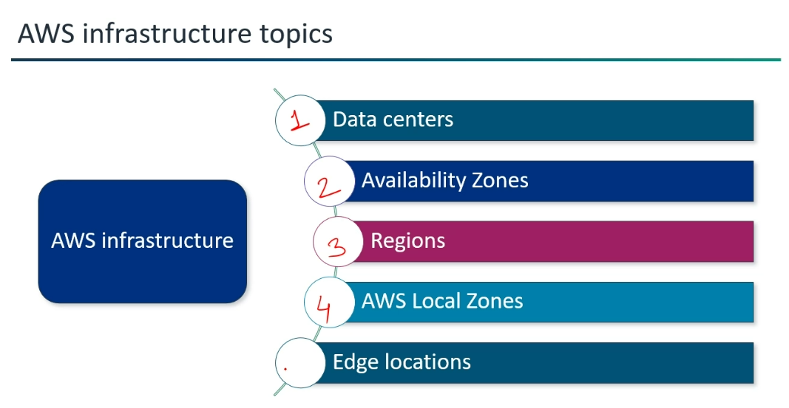

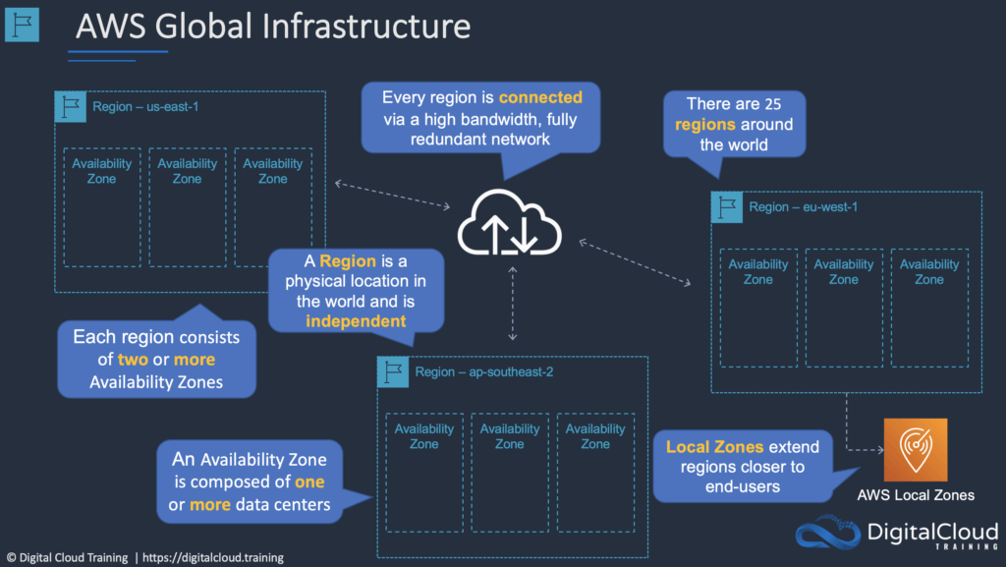
Data Centre:
Data Centre is a central hub for an organization's digital information and applications.
AWS has "Two data centers" in India,
In Asia Pacific Region,
1.Mumbai -->Region Code: ap-south-1 ---> Launched in June 2016
Availability Zones: (These all are also called "Data Centers")
1.ap-south-1a
2.ap-south-1b
3.ap-south-1c
If any natural disaster collapses "ap-south-1a", we do have "ap-south-1b" and "ap-south-1c".
2.Hyderabad -->Region Code: ap-south-2 --> Launched in November 2022
Availability Zones:
1.ap-south-2a
2.ap-south-2b
3.ap-south-2c
The "code for an Availability Zone" is its "Region code followed by a letter identifier"--> ap-south-1a .

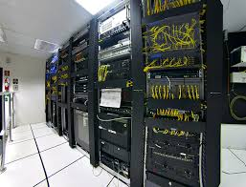
AWS Region:
*Each AWS Region is a separate geographic area and having at least three AZs.
*Region-->AZ-->Data Centers (Region inside AZ, AZ inside Data Centers)
Advantages of Region: Low Latency
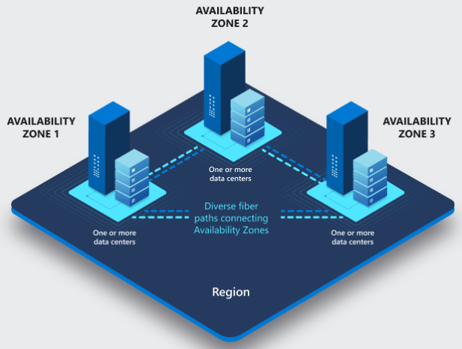
Availability Zones:
Advantages of Availability Zones: High Availability, Reliability(நம்பகத்தன்மை),
*Availability Zones (AZs) are physically isolated, meaning they have their own power, cooling, and networking infrastructure, but they are also interconnected within the same region with high-bandwidth, low-latency network links.
*Availability Zones in a Region are meaningfully distant from each other, up to 60 miles (~100 km) but logically/virtually grouped together. (Can communicate with each other).
*They are designed not to be impacted by a shared fate scenario like utility power, water disruption, fiber isolation, earthquakes, fires, tornadoes, or floods.
Add Disaster Recovery Strategy here…
*Region Code Region Name Availability Zones
ap-southeast-1 Singapore ap-southeast-1a ap-southeast-1b
(The code for an Availability Zone is its Region code followed by a letter identifier. For example, us-east-1a.)

AWS has "Two data centers" in India,
In Asia Pacific Region,
1.Mumbai -->Region Code: ap-south-1 ---> Launched in June 2016
Availability Zones: (These all are also called "Data Centers")
1.ap-south-1a
2.ap-south-1b
3.ap-south-1c
If any natural disaster collapses "ap-south-1a", we do have "ap-south-1b" and "ap-south-1c".
2.Hyderabad -->Region Code: ap-south-2 --> Launched in November 2022
Availability Zones:
1.ap-south-2a
2.ap-south-2b
3.ap-south-2c
The "code for an Availability Zone" is its "Region code followed by a letter identifier"--> ap-south-1a .
Local Zones (Mini AWS Data Centers):
*Local Zones are like mini-AWS data centers, where we can launch the resources and also we can place our resources of compute, storage and services in LZ. Local Zones are positioned much closer to specific large cities or population centers.
*Local Zones are extensions of a Region but placed in a city where no AWS Region exists.
Use Local Zones if your users in a specific city (like Delhi or Los Angeles) are complaining about lag.
*It is not required that all the regions should possesses Local Zones.
*Use Case: It offers Super Low Latency (single-digit millisecond latency) and so there will be a greater performance and provide a much smoother experience to the your end users.
*Costing will be higher for LZ than AZ.
*AZ-->High Availability, Reliability
LZ--->As low as single-digit millisecond latency.
*As of now, Local Zones are available in 35 metropolitan areas around the world (17 in US; 18 Outside US).
Local Zones in India:
1) Delhi
2) Kolkata
Announced plans to launch in Chennai and Bengaluru.
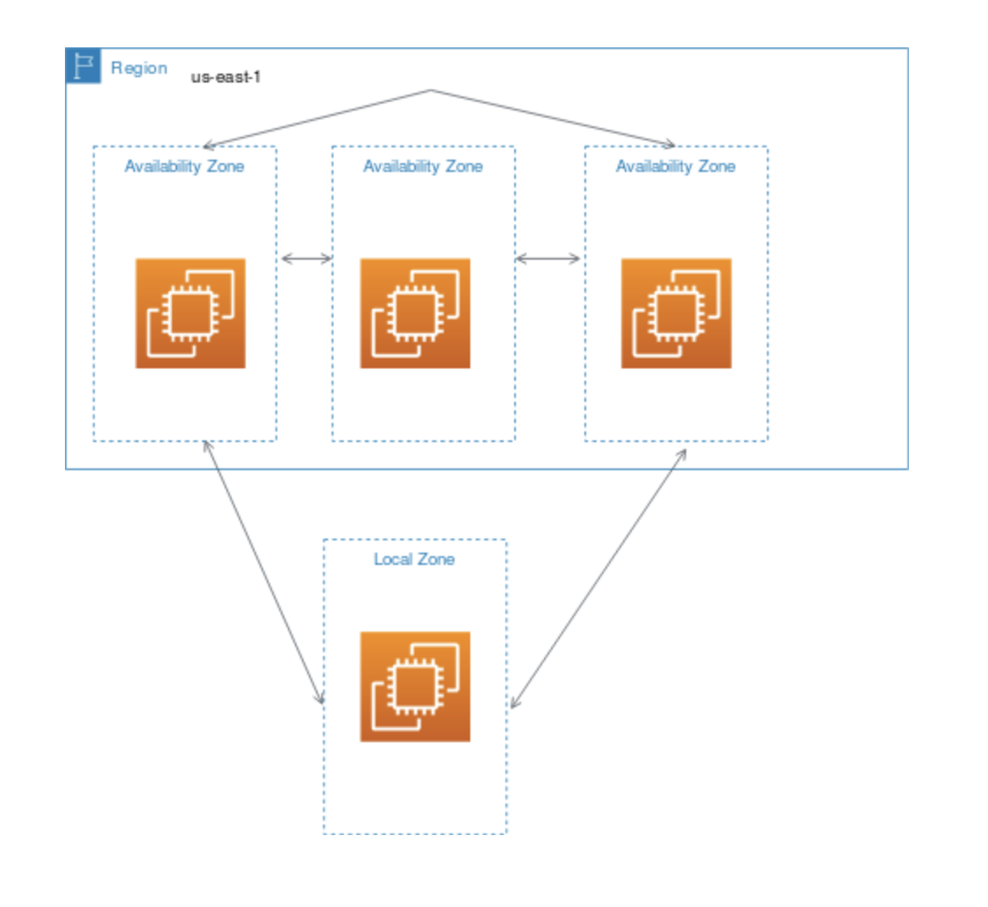
Edge Locations/Amazon CloudFront (Content Delivery Network -CDN)/
Points of Presence (PoPs):
*Edge locations are like mini AWS-data centers or caching servers, where AWS puts copies of your static content (images, videos, website files) so they can be delivered lightning-fast to users anywhere in the world, or where it handles DNS requests globally.
Edge locations are positioned closer to end users.
*CloudFront--> CloudFront is the service that manages the caching and content delivery.
In a way that, how long the content should be cached, we can configure it within your CloudFront distribution settings.
*CloudFront is a "Service".
Edge Location is "The Physical Infrastructure".
Flow:
When a user requests content through CloudFront…
*CloudFront directs the request to the nearest edge location.
* The edge location checks its local cache.
* If the content is in that edge location's cache (a "cache hit"), it's served directly from there.
* If not (a "cache miss"), the CDN fetches the data from your origin server.
(where your original content is stored, e.g., an AWS S3 bucket, an EC2 instance, or even your own web server).
*Then, CDN stores the data in the edge location and at the same time it delivers the content to the user.
* Once the Edge Location gets the image, it caches (stores a copy of) it locally.
*Edge Locations-->1)Only for content delivery ✓ (Can use services but only limited)
Not for hosting applications x
2)Globally delivers the content.
3)Edge location uses CloudFront (CloudFront is a Content Delivery Network [CDN])
*Other AWS services like Route 53 (DNS) and AWS Global Accelerator also utilize edge locations
to reduce latency and improve performance.

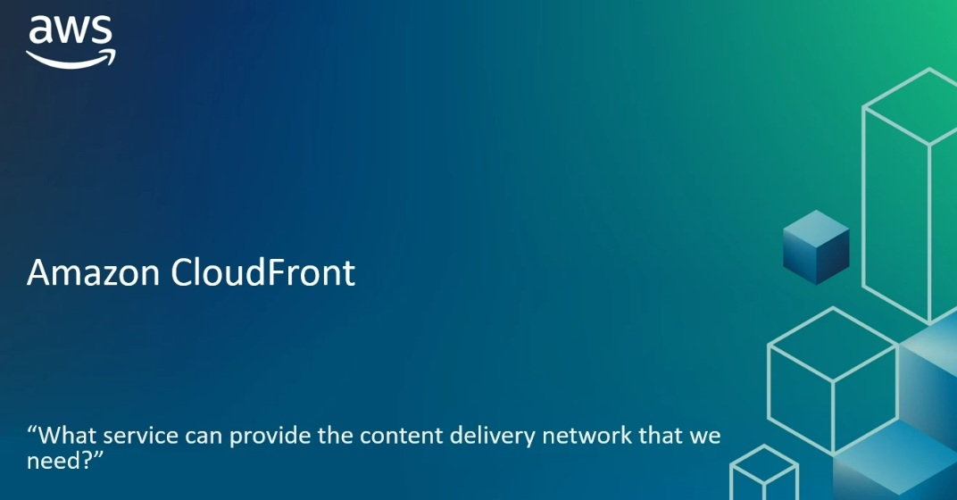
*Cloud Front --> Global Content Delivery Networks.
*Cloud Front Edge locations --> Cloud Front places in Edge location for quicker response to users.
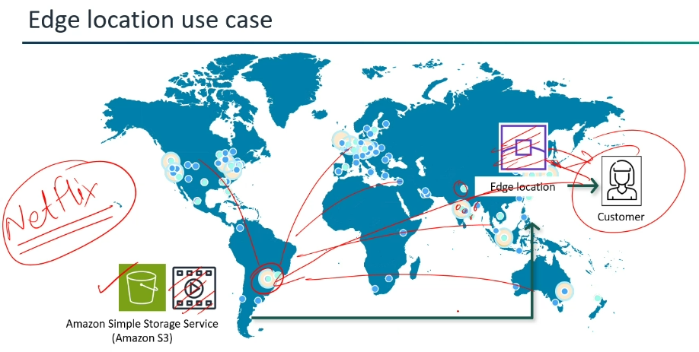

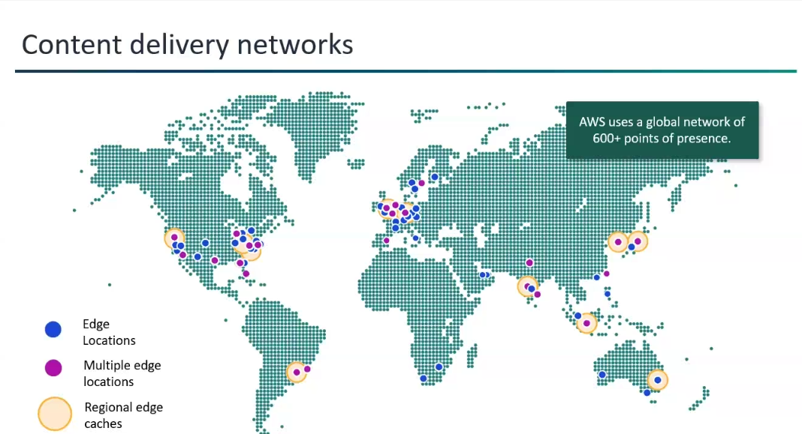

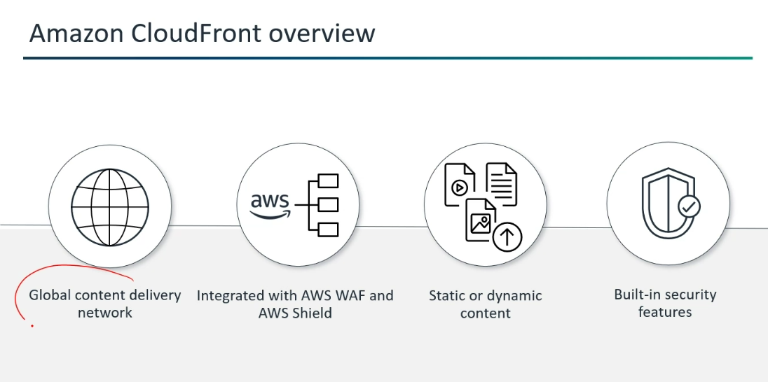

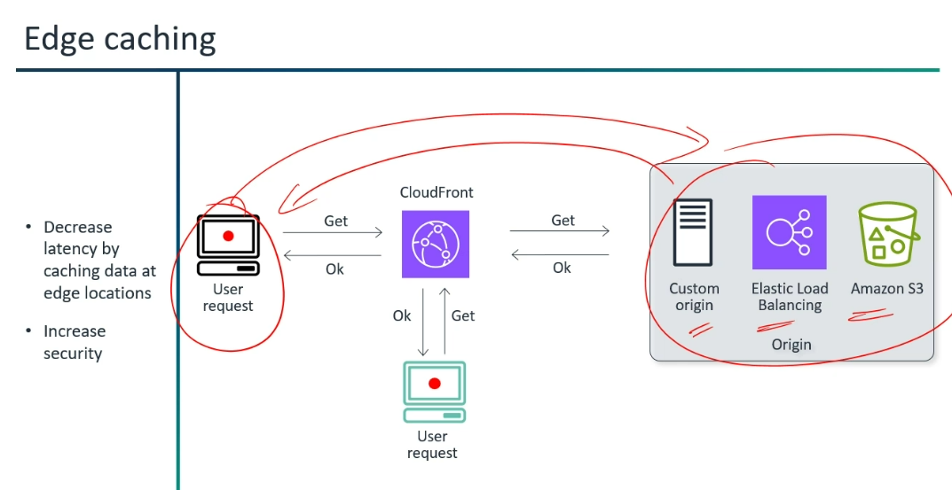
*Cloud Front Distribution --> Acts the user to fetch data from origin if cache is not cached by the CloudFront Edge location.
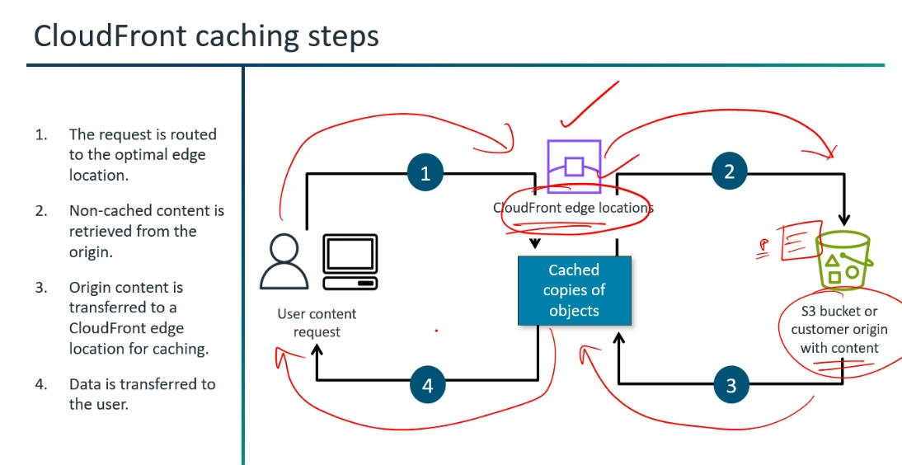

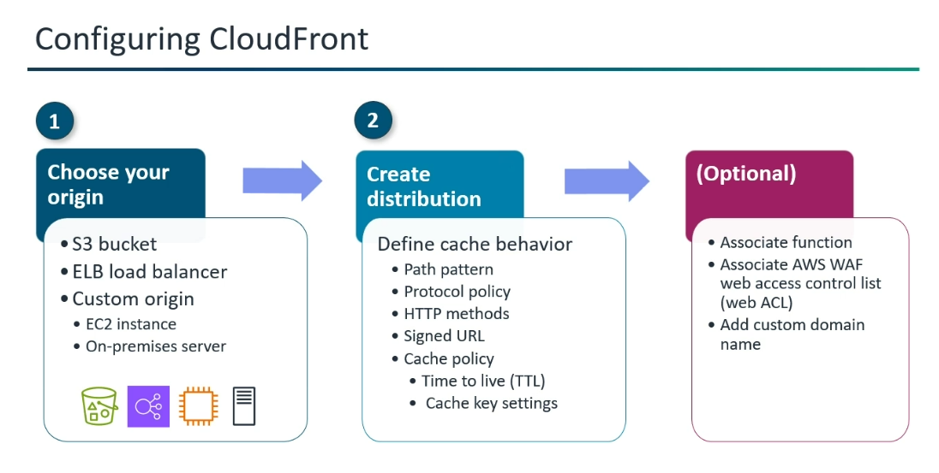

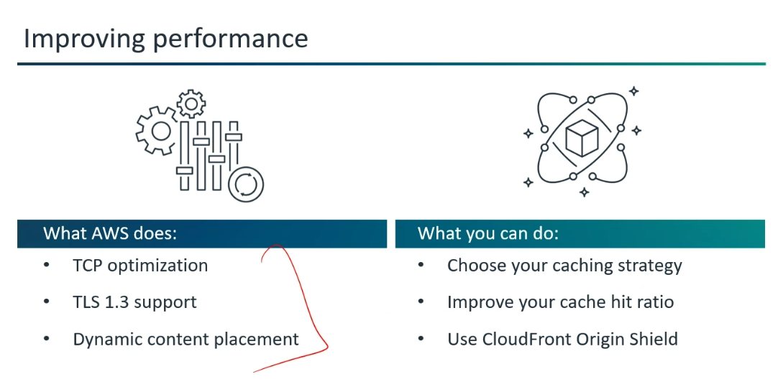

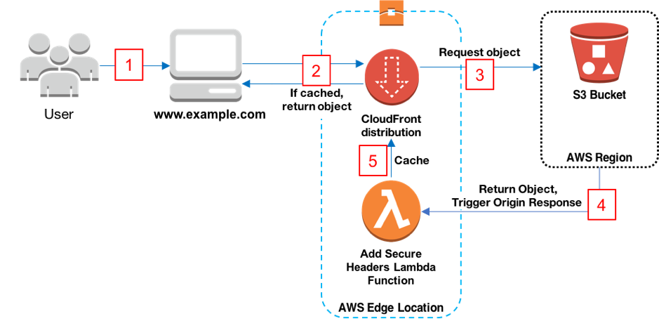
Regional Edge cache:
1)It has larger caches as compared to the edge location.
2)Since the data present in the regional edge cache expires in a definite amount of time.
3)We can configure the expiration of cached data by Time to Live (TTL) setting.
Default: If no specific TTL is set, a default expiration time for both "Edge location" and "Regional Edge cache" is 24 hours. (e.g., AWS CloudFront defaults to 24 hours).

* If the Regional Edge Cache has a valid, fresh copy: It serves that copy to the Edge Location. The Edge Location then delivers it to the user and refreshes its own cache with this content.
* If the Regional Edge Cache also does NOT have a valid, fresh copy (or it's also expired): Then the Regional Edge Cache will fetch the latest version of the data from the Origin Server. Once it receives the data, it delivers it to the Edge Location (which then serves it to the user), and both the Regional Edge Cache and the Edge Location cache the new, fresh copy.
*It helps to minimize the number of requests that hit the origin server.
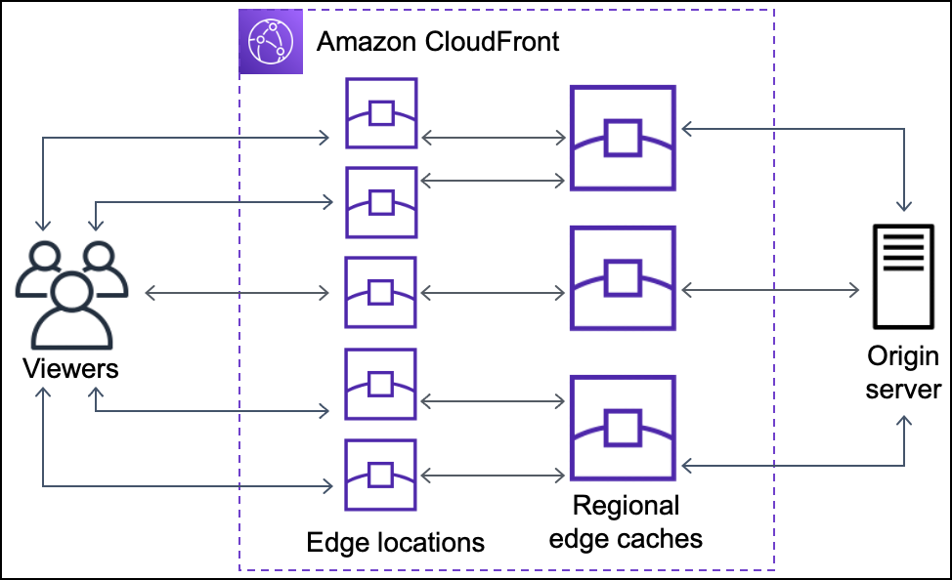
*Difference between Edge locations and Local Zones?
AWS Local Zones address low-latency requirements in specific geographic areas,
while edge locations are primarily used for caching and accelerating content delivery.
Similarities:
Local Zones and Edge locations, both are part of AWS's strategy for low latency, but they address different aspects of the architecture.
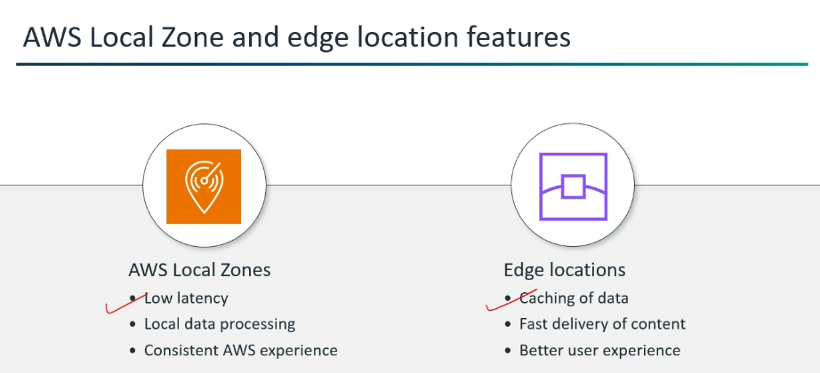

Wavelength Zones:

* Unlike traditional AWS Regions and Availability Zones which are large data centers, Wavelength Zones is to deploy of AWS infrastructure directly within the telecommunications providers' (like Verizon, Vodafone, KDDI, SK Telecom, Bell, British Telecom, Orange) 5G networks.
* Designed for "Mobile edge computing and Ultra-low latency for 5G devices" by embedding AWS infrastructure within carrier networks ( telecommunications providers ).
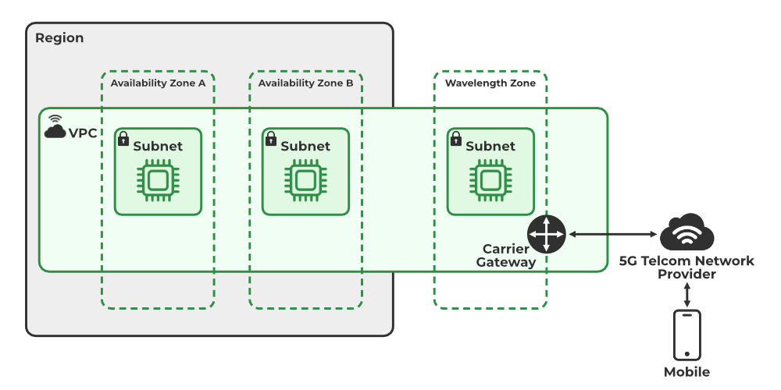

AWS Outposts:

*A physical rack or server (or multiple) containing AWS-designed hardware (compute, storage, networking) that you
deploy in your "Own data center" (like a smaller edge site), but it's still fully managed by AWS.
*You get the benefits of AWS locally, like low latency and data residency, while using the same familiar AWS tools and APIs as in the cloud.

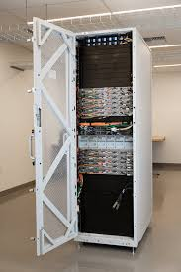

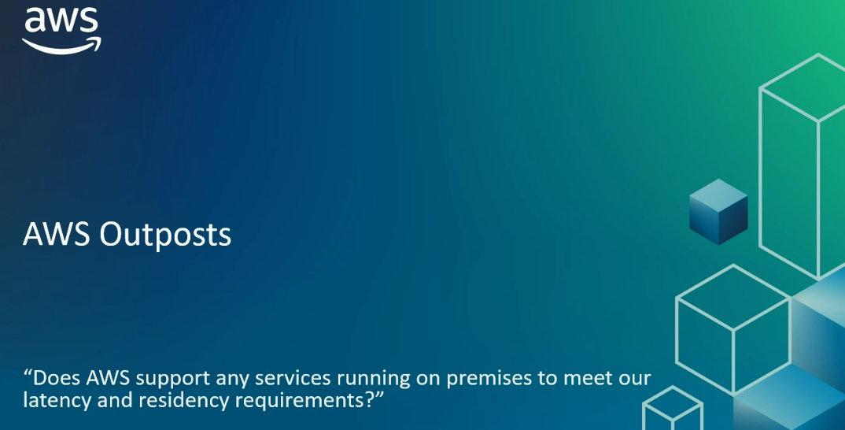

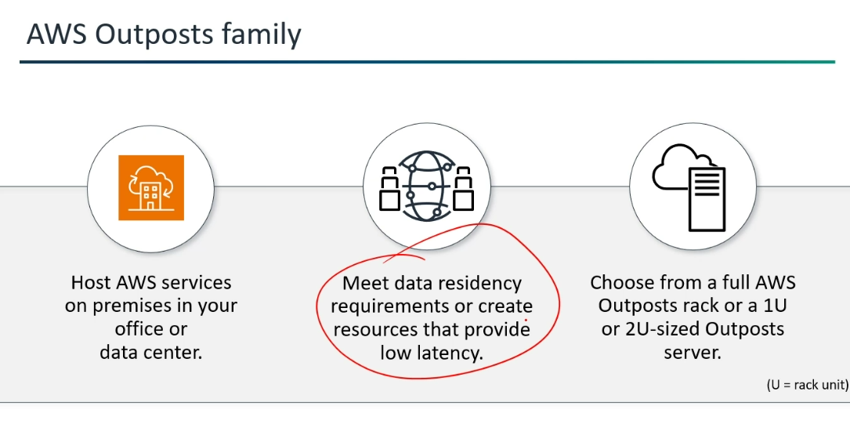

*1U and 2U refer to the height of the equipment that can be mounted in the rack.
"U" representing a rack unit.
*No, a 2U rack server is not simply a combination of two 1U servers. While a 2U server is twice the height of a 1U server.
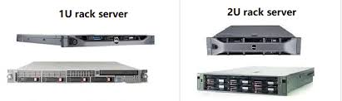

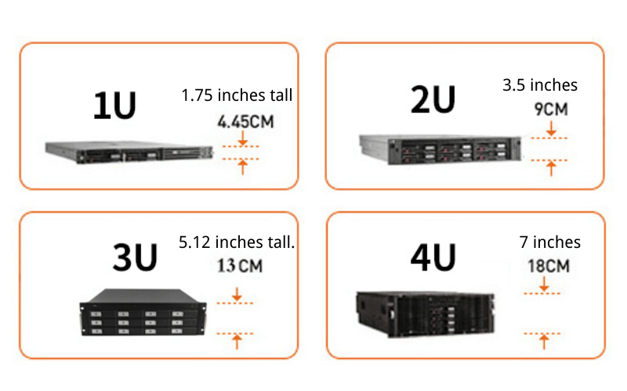

*AWS Outposts rack contains AWS Outposts Servers.

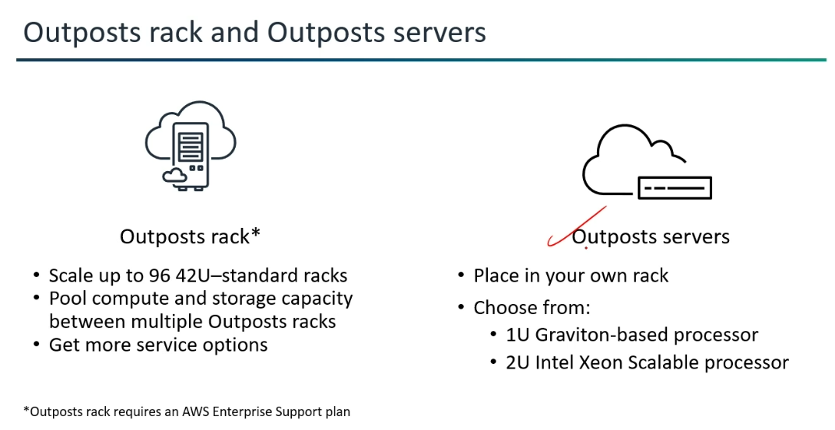
*VPC Spans Regions and AZs: Extend your VPC to the Outpost and then you create a new Outpost subnet.
You specify the Amazon Resource Name (ARN) of your Outpost when creating this subnet.
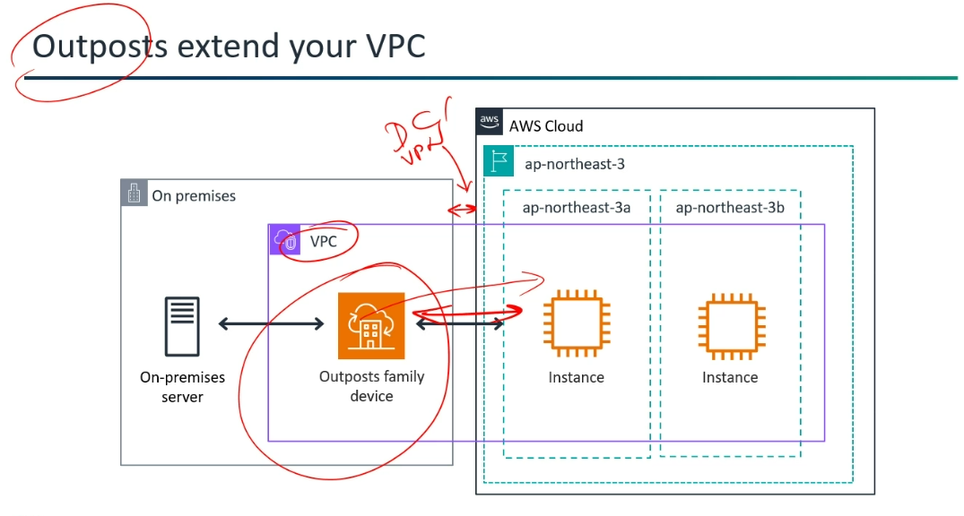

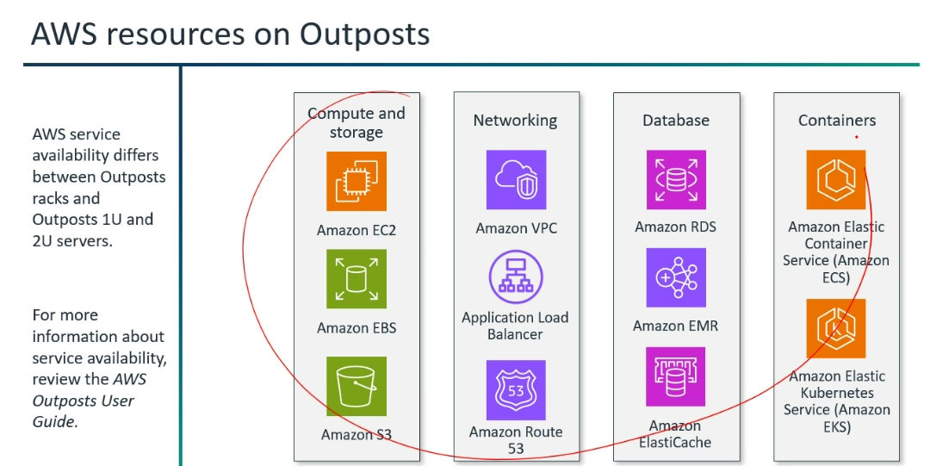

Factors must be considered when picking an AWS region:
*Which factors must be considered when picking an AWS region?
(GLSC--> To remember)
1)Governance (the way that organizations or countries are managed at the highest level)
2)Latency
3)Service Availability
4)Cost
One of the factors should get compromised to get one another.
[If Latency needs to be low, obviously cost is going to high.)
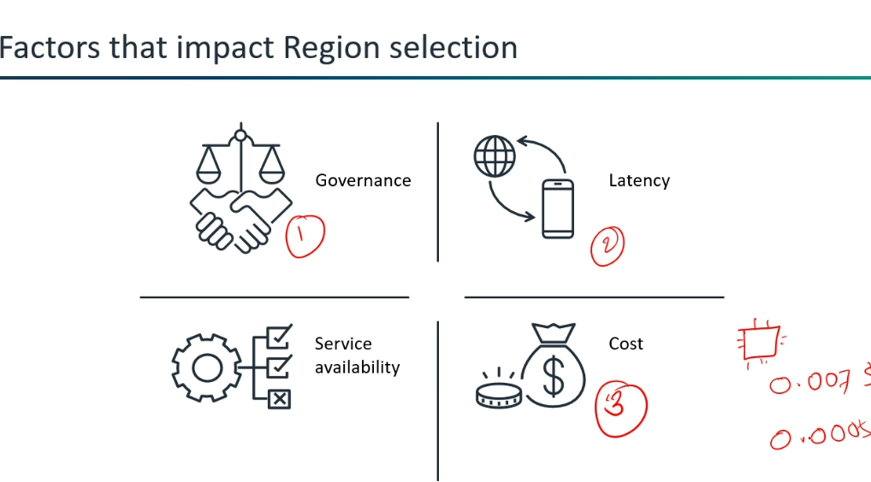

AWS Architect Responsibilities and AWS Well-Architected Framework Pillars:
*How can we build your cloud infrastructure according to the best practices?
AWS Architect Responsibilities and AWS Well-Architected Framework Pillars.
AWS Architect Responsibilities:
(PRB --> To remember)
1)Plan
2)Research
3)Build
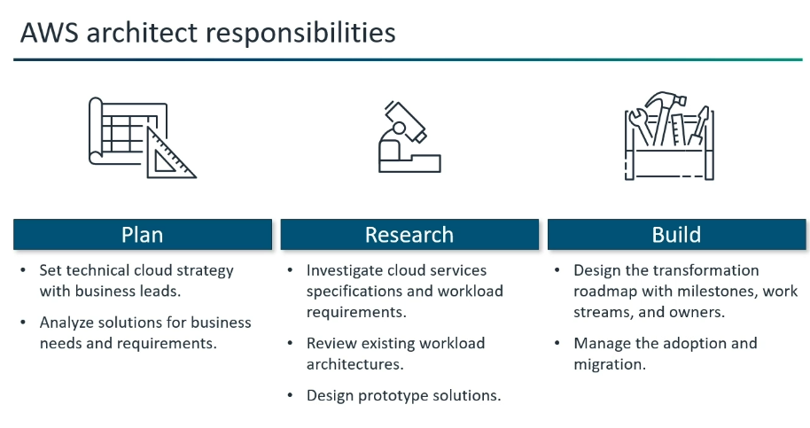

AWS Well-Architected Framework Pillars:
(SPC ORS --> To remember)
1)Security
2)Performance Efficiency
3)Cost optimization
4)Operational Excellence
5)Reliability
6)Sustainability
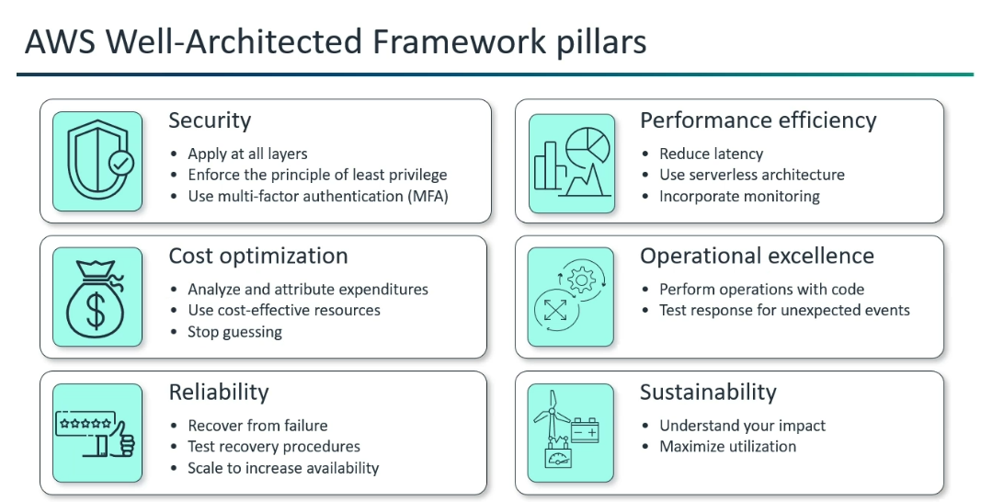

Q&A:
*Why no. of datacenters and servers are not disclosed in Documentation?
1)Security
2)The number is not going to be constant.(Servers may get launched if required or else servers will be destroyed in if it is not need)
*AZ to AZ connection?
Will share the complete architecture or only compute section to AZ. Only motive is (Context) "Application should get accessed by the end user.)
*Why "Security" is called least privilege?
The principle of least privilege restricts user access to only what is necessary for their job functions to minimize potential damage from attacks.
*What is the primary benefit of deploying applications into multiple Availability Zones?
High availability for resources.
*Which item is a cluster of data centers within a geographic region with low latency network connectivity?
Availability Zones.
*How many VPC per region in AWS?
The answer is 5.
Name Default Adjustable
VPCs per Region 5 Yes
Subnets per VPC 200 Yes
IPv4 CIDR blocks per VPC 5 Yes (up to 50)
IPv6 CIDR blocks per VPC 5 Yes (up to 50)
VPC Block Public Access exclusions per account per Region 50 Yes.
*The main three types of cloud computing are public cloud, private cloud, and hybrid cloud.

